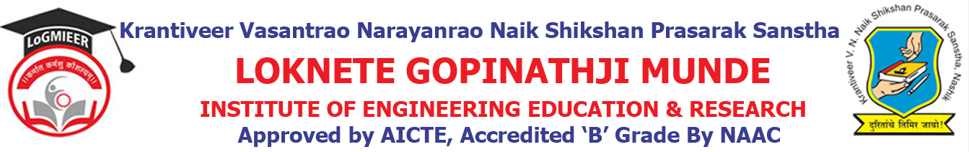
Department of AIML Engineering
ACADEMIC CALENDER-2021-22 SEM I
Sr. No. | Details of Activities | Weeks & Dates
1 | Course File & Practical File Checking | Week 1 | 14/06/2021
2 | Commencement of Teaching: TE & BE | Week 1 | 15/06/ 2021
3 | Commencement of Teaching: SE | Week 2 Onwards | 20/08/2021
4 | Unit Test | Week 5 Onwards | 02/09/2021 to 06/09/2021
5 | Feedback Phase I | Week 10 | 30/08/2021
6 | Academic letter to parent | Week 10 | 30/08/2021
7 | In-Sem Exam | Week 11 | 07/09/2021
8 | Expert Talk | Week 03 to Week 13 | 18/08/2021 to 23/08/2021
9 | Value Added Courses/Workshop | Week 03 to Week 13 | 18/08/2021 to 23/08/2021
10 | Academic letter to parents | Week 03 to Week 13 | 18/08/2021 to 23/08/2021
11 | Industrial Visits | Week 12 | 16/09/2021
12 | Parent Meet | Week 15 | 04/10/2021
15 | Feedback Phase II | Week 16 | 10/10/2021
16 | Academic Letter to Parents | Week 16 | 10/10/2021
17 | Final TW Sub-mission | Week 16 | 10/10/2021
18 | Remedial Classes | Week 16 | 10/10/2021
19 | Conclusion of Academic: TE& BE | Week 21 | 20/10/2021
20 | Conclusion of Academic: SE | Week 18 to Week 21 | 12/10/2021
21 | Theory Exam | Week 19 Onwards

Prof. S. S. Shinde Prof. A. A. Pundlik
Academic Co-ordinator HOD

